State of Delaware

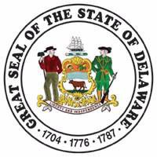

Continuous Improvement Practitioner Program
Building our capacity for innovation and efficiency in state government

Sponsored by
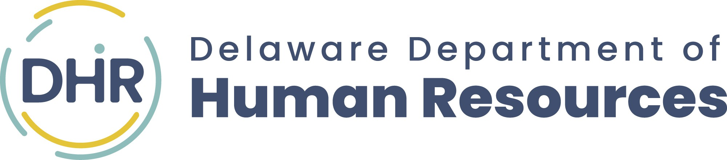
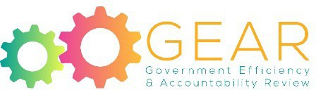

Funding provided by the
First State Quality Improvement Fund

Continuous Improvement Practitioner Program

Purpose
The purpose of the Continuous Improvement Practitioner (CIP) Program is to increase the State’s internal capacity to promote, facilitate, and implement systematic and sustainable improvement efforts by developing groups of skilled practitioners to lead and support those efforts. Participants must be nominated by their organization and will be expected to use the skills and knowledge gained to make ongoing contributions to improve efficiency and effectiveness of their organizations. The CIP program provides training in the areas of project management, process improvement, and change management. The program is also intended to foster connections and relationship building among participants to establish a diverse community of continuous improvement practitioners across organizations that will continue to assist and support one another as contributing members of the GEAR Field Team.

Program
Through practical exercises and collaborating on an actual State project, the participant will gain valuable skills in three key areas:
- Project Management Foundations: Covers the fundamental knowledge, terminology, and processes of effective project management. To ensure our project management methods are aligned with best practices, the training leverages the body of knowledge, and glossary of terms, established and maintained by the Project Management Institute(PMI).
- Lean Process Improvement: Provides an overview of the principles of Lean thinking and how they can be applied in state government. It takes an in-depth look at tools and techniques to achieve operational excellence and how to build a culture that supports continuous improvement.
- Change Management Certification: Gives participants the knowledge, skills, and tools to facilitate successful change initiatives. It also provides guidance on how to integrate change management with project management and lean process improvement efforts.

Eligibility
This program is designed for State employees who are currently in or who will fill a role responsible for continuous improvement in their organizations. Past participants have included directors, section managers, project managers, project team members, organizational development specialists, and quality assurance professionals, among others. Each participant shall provide a real-world project idea, agreed to by their leadership, that may be developed during the training. Individuals will work in teams to develop a project with the aim to develop their ability to take on and lead continuous improvement efforts. Agency leadership is expected to support program graduates by giving them dedicated time and resources to lead continuous improvement projects.
Team nominations are encouraged. Because this program incorporates actual State project work, we encourage teams of employees working on a common project to enroll in the program together. There is a limit of four team members per project, and each member must submit an application. Please note that not all team members may be accepted.

Commitment
To complete the program, participants must attend all scheduled training, as well as spend additional time outside of the training schedule for required project work. Participants will be required to make a final presentation to demonstrate their ability to apply the content covered in the training. After completion of the program, graduates are expected to use the skills and knowledge gained to make on-going contributions to continuous improvement efforts in their organizations. Participant's commitment also extends to becoming a member of a broader community and contributing membership on the GEAR Field Team.

Cost
This training is being fully funded by the First State Quality Improvement Fund.

Benefits
In addition to skills and knowledge provided, participants who complete the program will have enough educational hours to meet the requirements to take the Certified Associate in Project Management (CAPM) Exam, will receive 2.4 Continuing Education Credits from the University of Delaware, and earn PMI, Human Resources Certification Institute (HRCI), and Certificated Change Management Professional (CCMP) credits. Participants will receive Prosci Change Management Certification and also be granted Delaware Quality Partnership Membership for one year.

Continuous Improvement Practitioner Certification Program Application for Admission
Save this form to your computer before attempting to complete it.
Download and save this PDF form to your computer or network drive, and then open it with Adobe Reader and fill it in. Save changes as a new file when you are done and forward it to your supervisor for approval.

Name: | Preferred Name (Optional): | Preferred Pronoun (Optional):  Select One
Job Title |  | Employee I.D.
Department/Division:
Work Address: | City: | Zip:
Email Address: |  | Phone Number:
In case of an emergency, please provide us your cell phone number:
Your major job responsibilities
List any education, training, or work experiences you have in the area of continuous quality improvement, including any quality related certifications or degrees

List any memberships in professional groups such as the American Society of Quality (ASQ), Delaware Quality Partnership (DQP), Society for Human Resource Management (SHRM), or Project Management Institute (PMI)
What benefits do you expect to gain from participating in this program – both for yourself and your agency?

CONFIDENTIALITY NOTICE: Information contained in this application is confidential.

Potential Project Information
As part of this program, you are expected to work with a small team of other participants to apply the knowledge and skills developed in the training to a real, work-related project. Consequently, each applicant is required to include a description of a potential project or process improvement opportunity that could be used as the source for this small team work. Please complete the section below to provide a description of your potential project.
While there is no guarantee that your project will be chosen as a team project, we will use this description to evaluate your application (i.e., you will have significant opportunity to apply the training to your work) and to determine potential placement on a team of other participants with similar project opportunities or areas of interest.

What makes a good project for this program?
  - The project is at an early stage and there is significant opportunity to apply project management and/or process improvement to influence outcomes
  - The project is of a manageable size and complexity or it is possible to focus on a portion of the overall project.
  - You have knowledge of the reasons your organization has decided to implement the project.
  - You have knowledge of the project details (objectives, scope, timeline,…)
  - You have knowledge of the groups that will be impacted by the project and the types of impacts they will experience.

Please note: If you do not currently have a project underway, you can use this section to describe a project to which, if accepted, you would be prepared to commit significant time working on during – and after – this program.

What is the name of the project?

Are any other applicants to this program working on this project with you? If yes, please provide their names. If possible, complete this project profile together to collaborate on the responses.

Provide a description of the project, including both the nature and the scope of the work involved.

What are the project objectives? (What is the project intended to achieve?)

Does the project have a sponsor? If so, please provide name of project sponsor.

My project sponsor is aware of this nomination.

Commitment Statement
If you are accepted into this program, you must agree to the following commitments:
- Attend all training courses and complete all in-class and out of class assignments. If you miss any of the required courses, your agency may be billed for cost of that training.
- Make a final presentation on a project you worked on during the program that will be added to the GEAR Program Portfolio.
- Agree to facilitate and lead continuous improvement efforts in your agency after the program is complete
- Become a contributing member of the GEAR Field Team Please sign below if you agree to these commitments:

Typing your name will constitute your signature Date

Endorsements
To be considered for this program, the endorsement of both your supervisor and cabinet secretary are required.
By signing this endorsement, I support this employee’s participation in the program, granting them time away from their normal workload to complete the necessary training, and will continue to support them in the application of the knowledge and skills obtained. I also understand that if the employee fails to attend any training sessions that my agency may be responsible for the cost of those sessions.

Supervisor (Typing your name will constitute your approval) Date

Cabinet Secretary/Organization Leader/Agency Head (Typing your name will constitute your approval) Date

Save

Deadline for submitting application is December 3rd , 2026.
Once your application has been completed and signed, please click the save button above to save to your computer.

To submit your completed application, please upload it to our Application Portal

