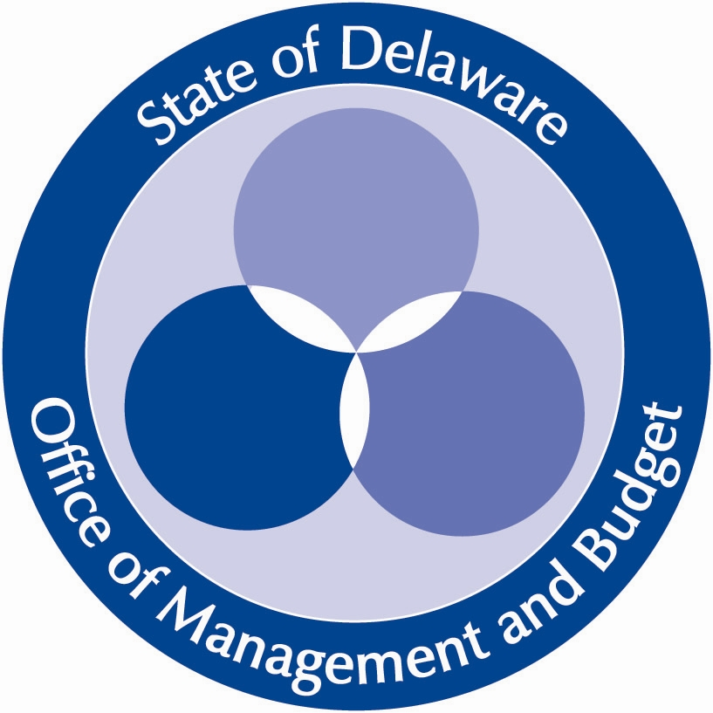
State of Delaware
Department of Human Resources

GOVERNOR’S
TEAM EXCELLENCE
AWARD
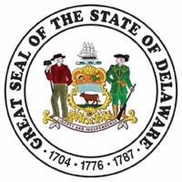

AWARD CRITERIA
&
2018 NOMINATION FORM

Statewide Training and Organization Development
Improving the Performance of State Government

Team Excellence Award Criteria
The criteria for the team evaluation are grouped in two categories: Team Operation (weighted at 50%) and Results (weighted at 50%). Teams must excel in at least one criterion from each of these categories; teams may re-apply (except the award recipient) and must have completed some of the team’s work in 2018.

TEAM OPERATION (50%)
Teams address many complex challenges and are structured according to the task at hand. Effective teams have operations with these characteristics:
Leadership – Excellent teams become role models for other teams in the organization. They focus on goals, excel at communication and lead their agencies to higher standards.
Alignment with Organization Mission and Strategic Goals – Teams exhibit clarity of purpose in executing their charters and achieving goals in alignment with the organization’s strategic plan.
Use of Best Practices, Continuous Quality Improvement and Measurement Tools – Effective teams use group processes and fact-based decision making, employ tools and techniques that solve problems, improve work processes and create environments of continuous learning.
Team Work Processes – Successful teams strive for excellence with every task, excelling at communication, organization, employee and customer involvement, decision making and improvement strategies.
The nomination submitted will be evaluated in the areas of problem identification, root cause analysis, team approach, and solution implementation.

RESULTS (50%)
Results are measurable outcomes that contribute to the overall success of the organization. Results need to be aligned with the organization’s mission and represent measurable and sustainable performance. Statewide and/or national recognition may already have been achieved. Examples of outstanding results include:
Superior Operating Results - Permanent teams that produce outstanding results in direct support of the organization’s primary mission.
Outstanding Task or Project Completion – Temporary teams that solved a major problem, completed a difficult task, or provided timely emergency response.
Excellent Customer–Focused Results - Teams that addressed customer concerns and produced a direct and positive impact on customers.
Major Cost Savings - Teams that have produced significant resource savings in staffing effort and/or direct costs.
The results of the team will be evaluated in terms of significance to the state and the general public, and the tangible and intangible results achieved by the team.

Nominations
Nominations for the Governor’s Team Excellence Award must include a completed nomination form addressing the team operations criteria and results questions. No more than five additional pages may be submitted to address the criteria.

Endorsement
Nominations for the Award must be accompanied by an endorsement email or letter from the Cabinet Secretary or Agency Head.
Submission Deadline - December 4, 2018
Email nominations to Statewide_Training@state.de.us with the subject line: Governor’s Team Excellence Award. Nominations should be attached to an endorsement email or letter from the Cabinet Secretary or Agency Head.

Eligibility
Teams with six to 20 employees of state agencies and the courts are eligible. Teams with fewer than six should apply for the Delaware Award for Excellence and Commitment in State Service.
Note: Most high performing teams consist of a core group of no more than 20 people. Nominations with over 20 team members will not be considered. It is strongly recommended teams with more than 20 identify a core group or consider nominating multiple teams.
Selection Team
The Selection Team is appointed by the Governor. Members include a cabinet secretary, division director, union representative, Delaware Quality Partnership representative, Department of Human Resources representative and a member of the previous award recipient team.
Awards
Each year, one team is selected to receive the Governor’s Team Excellence Award. Team members are presented with certificates and a citation on the Award’s permanent plaque. The Governor presents the award at an event hosted by the team’s home agency. Teams considered in the final selection process may be recognized as finalists, and all teams nominated for the Governor’s Team Excellence Award are acknowledged and recognized by their agency.
For Further Information or Questions contact
Department of Human Resources/Statewide Training and Organization Development, Tel: 302-739-1990 or visit our website at http://hrm.omb.delaware.gov/orgdev/excellence.shtml

Governor’s Team Excellence Award
www.delawarepersonnel.com/orgdev

Nomination #:
For Internal Use only
2018 Governor’s Team Excellence Award - Nomination
Instructions - This is a fillable word form. Begin typing in the shaded area, and it will expand as you type or cut and paste in information. The tab key can be used to scroll to the next entry. To save the document, go to file menu and select “save as” and rename the file to include your team’s name and agency name.

Date: Click here to enter a date.
Team Name: Click here to enter text. (Note: Please use the exact title of the team to be recognized).
Department/Agency: Click here to enter text. Division:
Type of Team (choose one): Permanent: Place x here Project: Place x here
Dates of Significant Team Activity: From Click here to enter a date. To Click here to enter a date.
Team Leader’s Name/Title/Agency: Click here to enter text.
Address: Click here to enter text.
Telephone Number: Click here to enter text. Ext. Click to enter text. SLC: Click here to enter text.
Nominated By: Click here to enter text. Address (if different from above): Click here to enter text.
Telephone Number: Click here to enter text. Ext. Click here to enter text.
Team Members (this is exactly how the names will appear on the certificates and in the press release):
First Name | Last Name |  | First Name | Last Name

Summary Statement
Briefly describe your team’s composition, why it was created, and what its goals are. In addition, highlight the team’s major accomplishments over the past year and the impact of that success on state government and the public.

If selected, this statement will be used as the part of the Governor’s Team Excellence Award press release.
Limit 500 words

Click here to enter text.

Background
Provide any background information on the team or the organization that would be helpful to better understand the context of the team’s work.
Click here to enter text.

Team Operations Criteria
- Establishing the Team
  - Explain this team’s mission and why it was created.
Click here to enter text.
  - Explain how the team’s work supports the organization’s mission and goals.
Click here to enter text.
  - Identify how stakeholders and customers benefit from the team’s work.
Click here to enter text.
- Identifying Needs
  - Describe the process used to define the root causes and/or opportunities for improvement in the area the team was focused on.
Click here to enter text.
  - Explain how the team developed goals to address the needs identified in those causes and/or opportunities.
Click here to enter text.
  - Identify what measures were established to track and evaluate the team’s progress
Click here to enter text.
- Team Approach
  - Describe what actions were taken to prepare the team to work together.
Click here to enter text.
  - Explain the team’s approach to solving problems and making decisions.
Click here to enter text.
  - Describe how the team collaborated and supported one another to accomplish their goals.
Click here to enter text.
  - Describe how stakeholders and customers were engaged in the project.
Click here to enter text.
- Implementing Solutions
  - Describe the strategies and actions used to accomplish the team’s goals.
Click here to enter text.
  - Explain how management support was obtained to implement the strategies and action.
Click here to enter text.
  - Describe any obstacles or challenges the team faced and how they overcame them.
Click here to enter text.
  - Explain how the team used communication with each other and with customers and stakeholders to ensure their success.
Click here to enter text.

Results Criteria
- Describe the important results achieved by the team and the significance of those results.
Click here to enter text.
- Describe any secondary or indirect benefits from the team’s work.
Click here to enter text.
- Describe what the team did to ensure that the benefits and best practices obtained from their work were communicated and sustained in their organization.
Click here to enter text.

