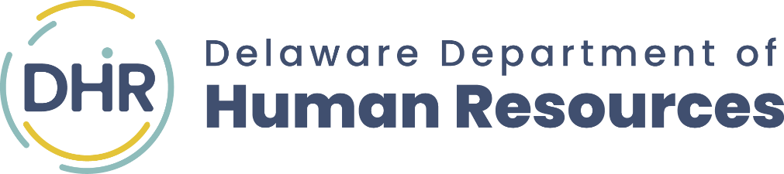

CERTIFICATE
of ACHIEVEMENT

THIS ACKNOWLEDGES THAT
INTERN NAME

HAS SUCCESSFULLY COMPLETED

•STATE OF DELAWARE•

INTERNSHIP PROGRAM
Erica Pratz, Program Coordinator

