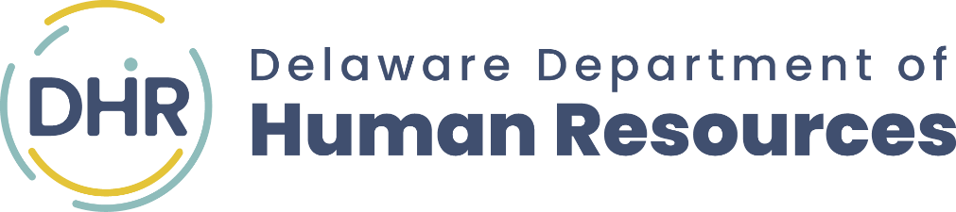

CERTIFICATE
of ACHIEVEMENT

THIS ACKNOWLEDGES THAT
STUDENT NAME

HAS SUCCESSFULLY COMPLETED

•STATE OF DELAWARE•

PATHWAYS WORK-BASED LEARNING PROGRAM
Erica Pratz, Program Coordinator

